|  |
| --- |
| Close-up image showing the leaf-sides of two oversized books side-by-side on a bookshelf, with additional books in soft focus background |
| HTML ASSIGMENT  Basics of HTML |
| |  |  |  | | --- | --- | --- | | Jenil Desai - 16 | 1/18/13 | Bsc.IT – Sem.1 – D2 | |

1. Create a webpage as per following instructions

File name: first.html

Title: your name

Head: This is my first page

Body content: Write 10 sentences on magnetic tape

<html>

    <head>

        <title>Jenil Desai</title>

    </head>

    <body>

        <center><h1>This is My First Page</h1></center>

            1. Longevity: Magnetic tape has been a reliable data storage medium for several decades, known for its long-term data retention capabilities.

            <br><br>

            2. Storage Capacity: Despite being surpassed by other storage mediums in recent years, magnetic tape still boasts an impressive storage capacity, making it suitable for long-term data archival.

            <br><br>

            3. Cost-Effectiveness: Magnetic tape remains a cost-effective option for large-scale data storage, especially for organizations with substantial data storage requirements.

            <br><br>

            4. Durability: It is resilient and can withstand physical wear and tear better than some other storage options, making it suitable for long-term storage in challenging environments.

            <br><br>

            5. Sequential Access: Magnetic tape is primarily designed for sequential data access rather than random access, making it suitable for applications that involve bulk data transfer and storage.

            <br><br>

            6. Use in Data Backup: Many organizations use magnetic tape for data backup purposes due to its cost-effectiveness and capacity for storing large volumes of data securely.

            <br><br>

            7. Compatibility: Although technological advancements have led to the development of newer storage options, magnetic tape remains compatible with many legacy systems, ensuring the accessibility of archived data.

            <br><br>

            8. Data Transfer Speed: While not as fast as some modern storage technologies, magnetic tape can still facilitate relatively quick data transfer for sequential read and write operations.

            <br><br>

            9. Reliability: When stored and handled properly, magnetic tape can be a reliable storage medium for preserving data integrity over extended periods, making it suitable for long-term archival purposes.

            <br><br>

            10. Energy Efficiency: Magnetic tape is an energy-efficient storage medium compared to many other options, consuming less power during both storage and retrieval operations.

    </body>

</html>

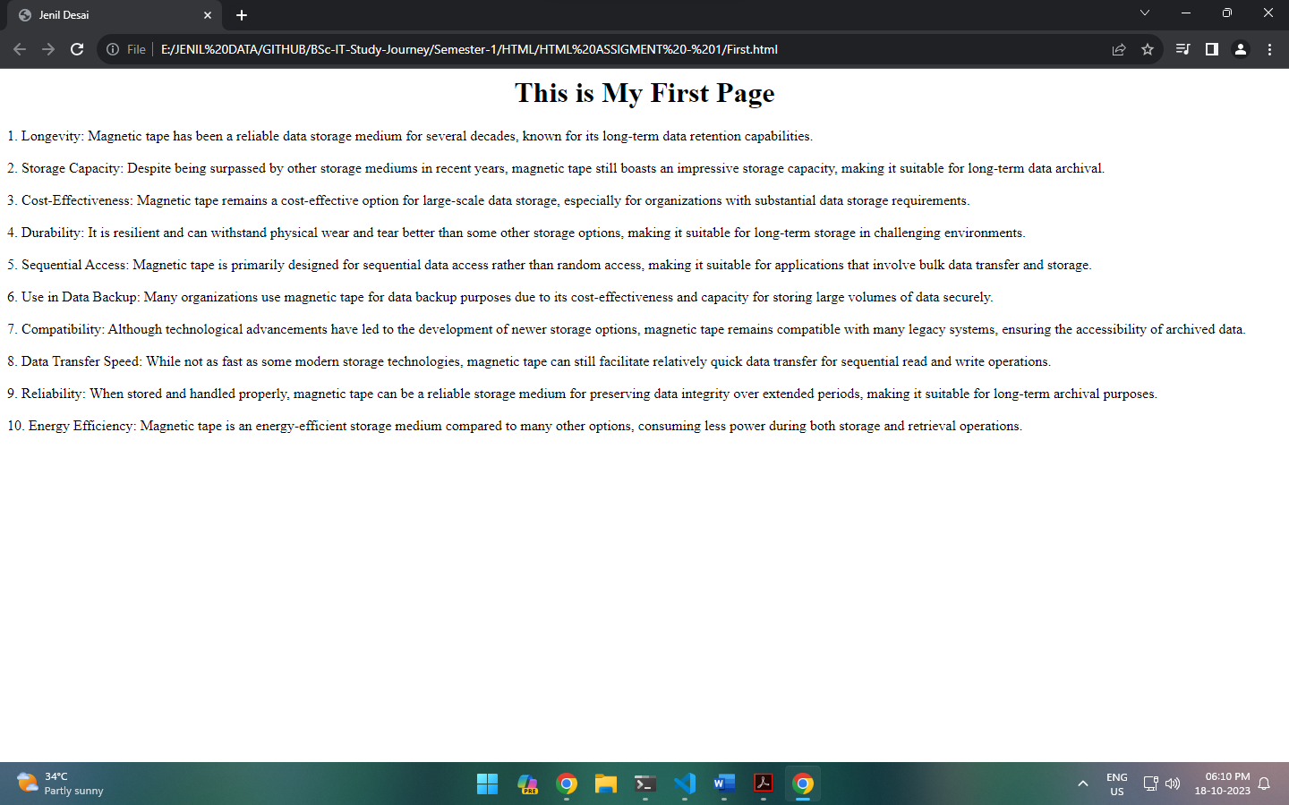

2. Create a webpage which contains details of magnetic disk with 15 sentences.

File name: para.html

Instructions:

Create paragraph after every 2 lines.

Display every sentence in new line.

Note: use <p> and <br> tag.

<html>

    <head>

        <title>

            Jenil Desai

        </title>

    </head>

    <body>

        <p>

            Magnetic tape is a medium for magnetic recording, widely used for storing data, music, and video. It consists of a thin, magnetizable coating on a long, narrow strip of plastic film. The tape is typically housed in a plastic cassette for easier handling.

            <br><br>

            The magnetic tape is composed of a base material, commonly made of polyester, and a magnetic layer typically made of iron oxide. The base film provides stability and strength to the tape.

            <br><br>

            The magnetic layer stores data in the form of magnetic patterns. These patterns are created by aligning the magnetic particles in a specific direction using a magnetic recording device.

            <br><br>

            Magnetic tapes are available in different widths and lengths to accommodate various data storage needs. The width ranges from 0.25 inches to 2 inches, with 0.5 inches being the most common for data storage purposes.

            <br><br>

            The tape is wound on two spools within the cassette, and the direction of the winding can be either linear or helical, depending on the recording technology.

            <br><br>

            Magnetic tape technology has evolved over the years, with different formulations for the magnetic layer, such as metal particles or metal evaporated films, providing higher storage density and better signal-to-noise ratios.

            <br><br>

            The use of magnetic tape is prevalent in data backup and archival storage applications due to its high capacity, durability, and cost-effectiveness. It is often used for long-term storage of critical data that needs to be preserved for extended periods.

            <br><br>

            Magnetic tape drives use read/write heads to access and modify data on the tape. The read/write heads operate by detecting and altering the magnetic field of the particles on the tape.

            <br><br>

            The speed at which data can be accessed from magnetic tape is generally slower compared to modern storage mediums like solid-state drives and hard disk drives. However, its advantage lies in its long-term stability and archival capabilities.

            <br><br>

            Despite being slower, magnetic tape has a high throughput and can transfer large amounts of data quickly. It remains a preferred option for large-scale data backup and long-term data retention in various industries.

            <br><br>

            Advancements in magnetic tape technology have led to the development of Linear Tape-Open (LTO) technology, which offers high storage capacity and faster data transfer rates, making it suitable for modern data-intensive applications.

            <br><br>

            Magnetic tape is susceptible to damage from environmental factors such as temperature, humidity, and dust. Proper storage conditions are necessary to ensure the longevity of the data stored on the tape.

            <br><br>

            Regular maintenance of the tape drives and careful handling of the tape cartridges are essential to prevent data loss and ensure the reliability of the stored information.

            <br><br>

            Magnetic tape continues to be relevant in industries like broadcasting, data storage, and scientific research, where the need for cost-effective, high-capacity data storage and archiving solutions is paramount.

            <br><br>

            Efforts are continually being made to enhance the storage density and performance of magnetic tape, ensuring its relevance in the face of advancing digital technologies and data storage requirements.

        </p>

    </body>

</html>

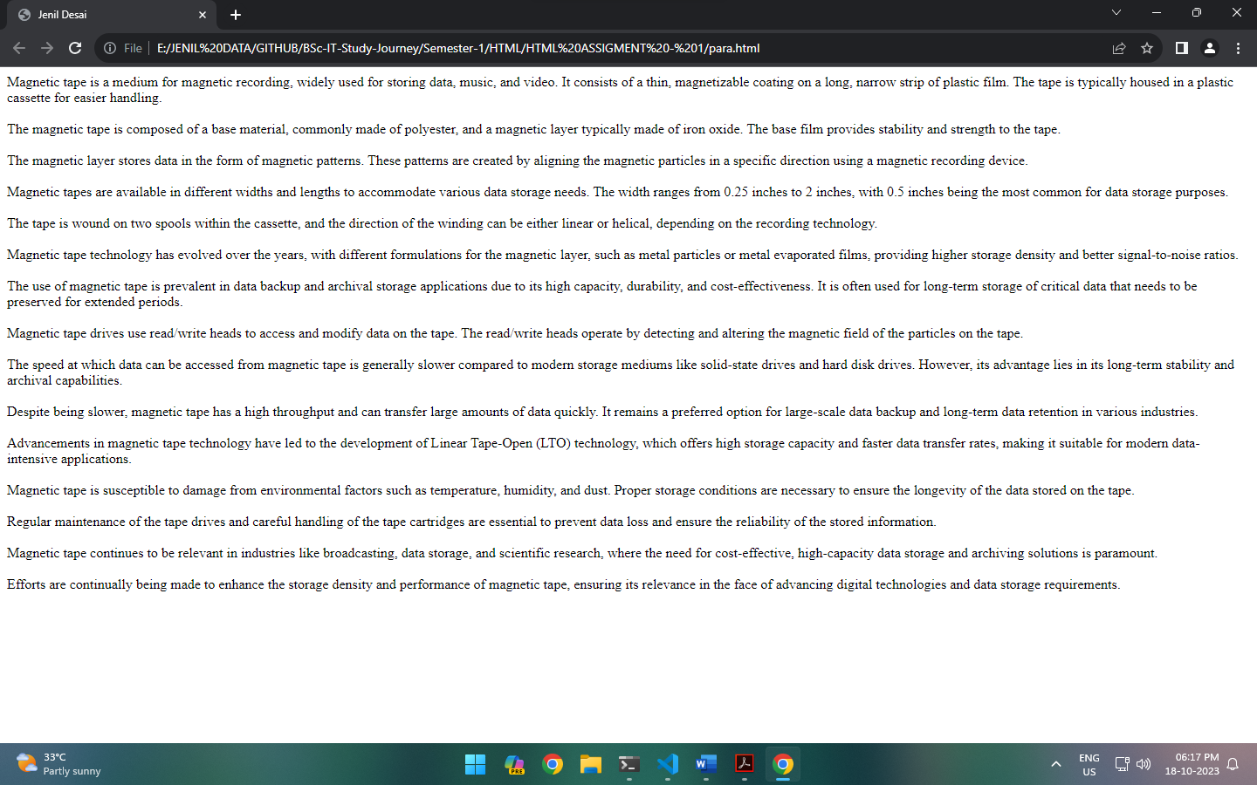

3. Create a table

File name: table.html

|  |  |  |
| --- | --- | --- |
| Roll No. | Name | Marks |
|  |  |  |

Display column titles in bold fonts.

Enter details of minimum 5 students.

Provide border.

<html>

    <head>

        <title>

            Jenil Desai

        </title>

    </head>

    <body>

        <center><h1>Student Details</h1></center>

        <table border="3" cellpadding="5" align="center">

            <tr>

                <th>Roll No.</th>

                <th>Name</th>

                <th>Marks</th>

            </tr>

            <tr>

                <td>01</td>

                <td>Pushpa</td>

                <td>29</td>

            </tr>

            <tr>

                <td>02</td>

                <td>Sriveli</td>

                <td>30</td>

            </tr>

            <tr>

                <td>03</td>

                <td>Konda Raddy</td>

                <td>29</td>

            </tr>

            <tr>

                <td>04</td>

                <td>Jolly Readdy</td>

                <td>21</td>

            </tr>

            <tr>

                <td>05</td>

                <td>Bhaver Singh</td>

                <td>26</td>

            </tr>

        </table>

    </body>

</html>

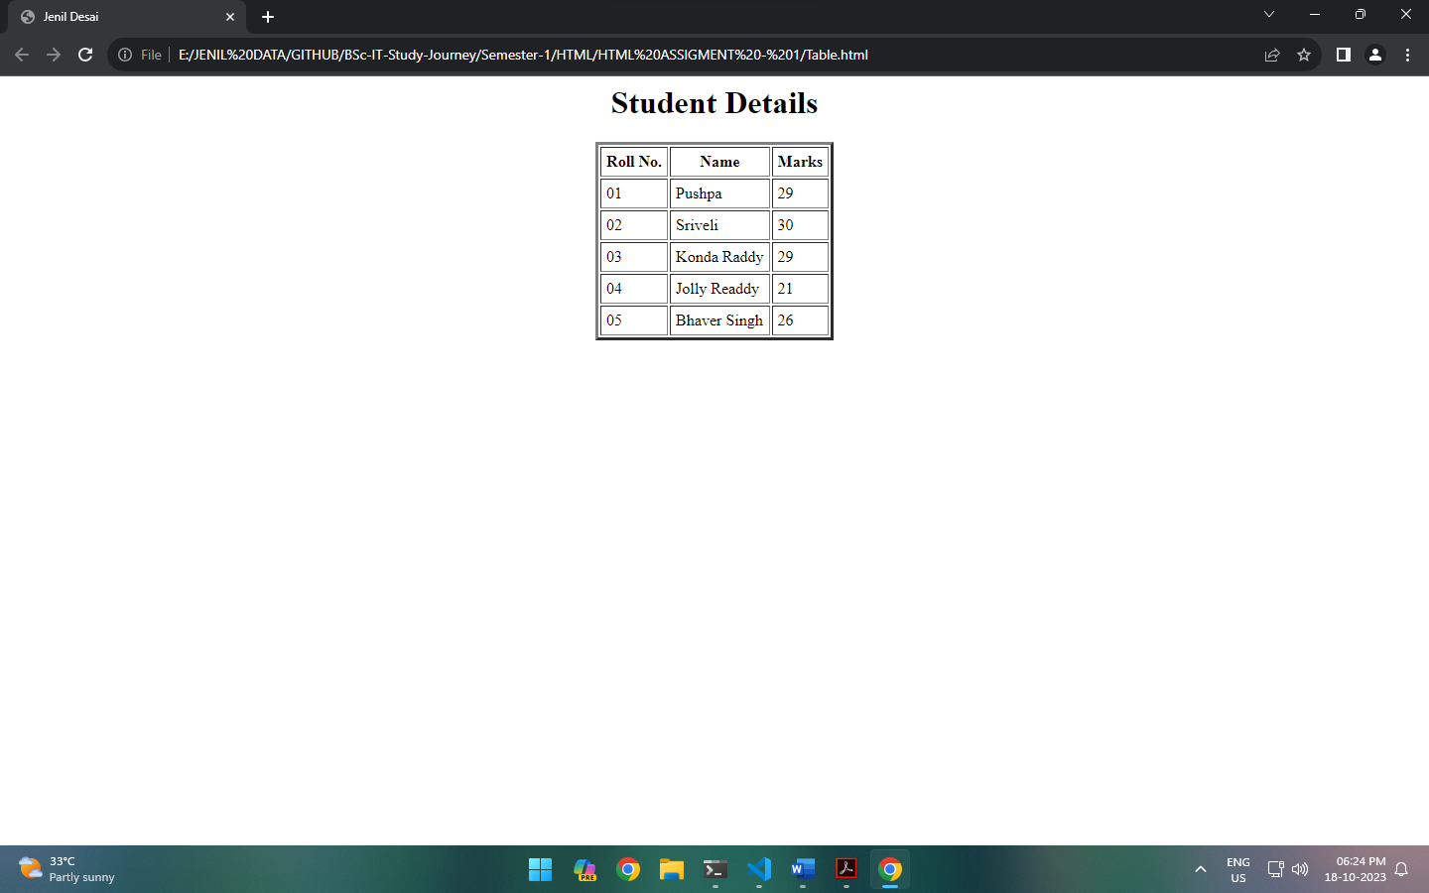

4. Create a table

File name: table_effect.html

|  |  |  |  |
| --- | --- | --- | --- |
| Employee Num | Employee Name | Department | Designation |
|  |  |  |  |

Display column titles in bold fonts.

Enter details of minimum 5 employees.

Keep background color of your choice.

Height and width of the table should be 60 and 40 respectively

Provide a green color border to table with thickness of minimum 5 points.

<html>

    <head>

        <title>

            Jenil Desai

        </title>

    </head>

    <body>

        <h1>Employee Details</h1>

        <table border="5" bordercolor="Green" height="60" width="40" bgcolor= #e6e6e6 cellpadding="10">

            <tr>

                <th>Employee Num</th>

                <th>Employee Name</th>

                <th>Department</th>

                <th>Desgination</th>

            </tr>

            <tr>

                <td>12345</td>

                <td>Sarah Johnson</td>

                <td>Human Resource</td>

                <td>HR Director</td>

            </tr>

            <tr>

                <td>23456</td>

                <td>Michael Smith</td>

                <td>Finance and Accounting</td>

                <td>Financial Controller</td>

            </tr>

            <tr>

                <td>34567</td>

                <td>Emily Williams</td>

                <td>Sales and Marketing</td>

                <td>Marketing Manager</td>

            </tr>

            <tr>

                <td>45678</td>

                <td>John Davis</td>

                <td>Research and Development</td>

                <td>Product Development Manager</td>

            </tr>

            <tr>

                <td>56789</td>

                <td>Jessica Brown</td>

                <td>Quality Assurance</td>

                <td>Compliance Officer</td>

            </tr>

        </table>

    </body>

</html>

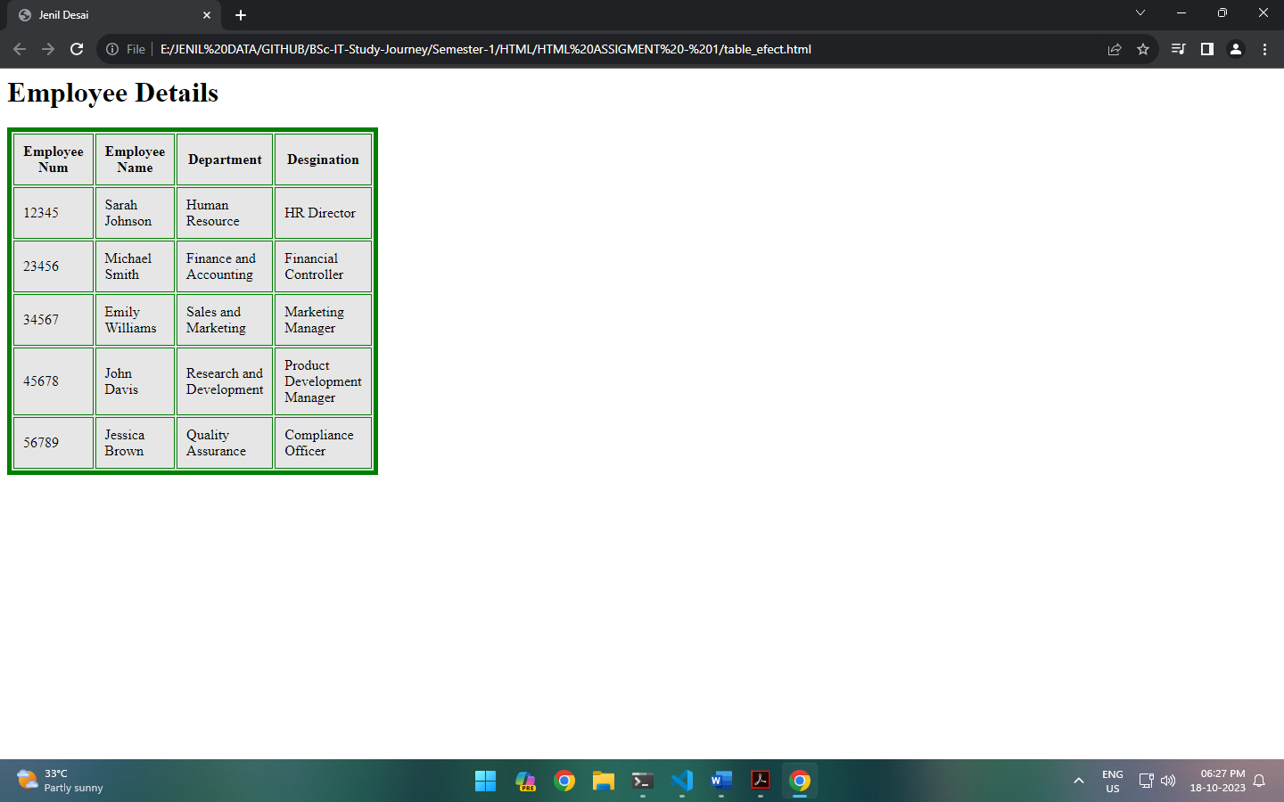

5. Create a table

File name: table_cell.html

|  |  |  |  |
| --- | --- | --- | --- |
| Book num | Book Name | Author Name | Price |
|  |  |  |  |

Display column titles in bold fonts

Enter details of minimum 5 books.

Display the table in the center of the screen.

Height and width of the table should be 50 and 50 respectively

Provide a blue color border to table with thickness of minimum 10 points.

Provide 10 points space between cells.

Provide gap of 15 points between content and cell border.

<html>

    <head>

        <title>

            Jenil Desai

        </title>

    </head>

    <body>

        <center><h1>Book Details</h1></center>

        <table border="10" bordercolor="Blue" height="50" width="50" cellspacing="10" cellpadding="10" align="center">

            <tr>

                <th>Book Num</th>

                <th>Book Name</th>

                <th>Author Name</th>

                <th>Price [$]</th>

            </tr>

            <tr>

                <td>12345</td>

                <td>The Luminaries</td>

                <td>Eleanor Catton</td>

                <td>18.99</td>

            </tr>

            <tr>

                <td>23456</td>

                <td>To Kill a Mockingbird</td>

                <td>Harper Lee</td>

                <td>12.50</td>

            </tr>

            <tr>

                <td>34567</td>

                <td>The Great Gatsby</td>

                <td>F. Scott Fitzgerald</td>

                <td>14.99</td>

            </tr>

            <tr>

                <td>45678</td>

                <td>1984</td>

                <td>George Orwell</td>

                <td>11.25</td>

            </tr>

            <tr>

                <td>56789</td>

                <td>Pride and Prejudice</td>

                <td>Jane Austen</td>

                <td>10.75</td>

            </tr>

        </table>

    </body>

</html>

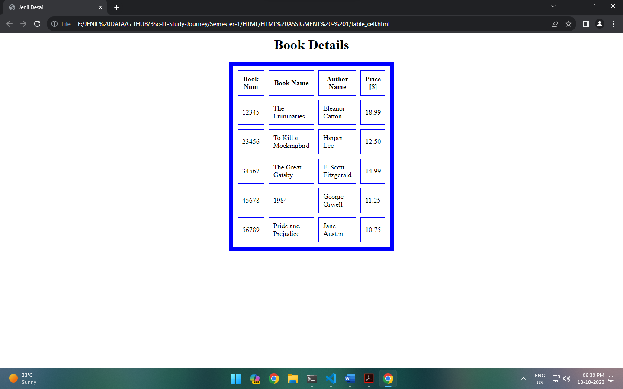

6. Open para.html file

Save it as formatting.html

Make first word of every paragraph bold.

Make second word of every paragraph italic.

Highlight any one word in every paragraph.

Give effect of cancelled text (strike out) to last word of every paragraph.

Add new paragraph content as follows:

This file shows all the tags for formatting in html providing various effect such as bold, italic, underline, strike thorough, highlighted text and many more. This effects can be provided using various formatting tags available in html. There are special tags for superscript and subscript also.

For e.g. H2O, CO2, 105, 58

<html>

    <head>

        <title>

            Jenil Desai

        </title>

    </head>

    <body>

        <p>

            <b>This</b> <i>file</i> shows all the tags for <mark>formatting</mark> in html providing various effect such as bold, italic, underline, strike thorough, highlighted text and many <del>more</del>.

            <br><b>This</b> <i>effects</i> can be provided using various <mark>formatting</mark> tags available in <del>html</del>.

            <br><b>There</b> <i>are</i> special tags for <mark>superscript</mark> and subscript <del>also</del>.

            <br><b>For e.g.</b> H<sub>2</sub>O, CO<sup>2</sup>, 10<sup>5</sup>, 5<sup>8</sup>

        </p>

    </body>

</html>

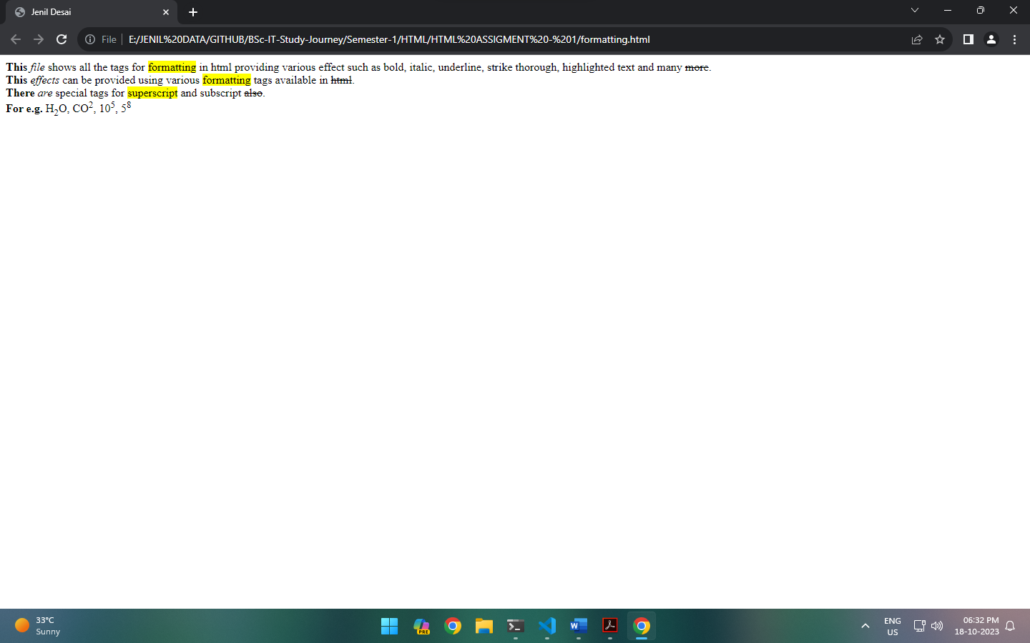

7. Create a table as follows:

File name: table_merge.html

|  |  |  |  |
| --- | --- | --- | --- |
| Nutrition Details | | | |
| Product | Calories | Fat | Vitamin |
| Soup | 55 | 20 | Vitamins A |

Display column titles in bold fonts

Enter details of minimum 5 products as per given example of Soup.

Display the table on the right of the screen.

Provide a yellow color border to table with thickness of minimum 7 points.

<html>

    <head>

        <title>

            Jenil Desai

        </title>

    </head>

    <body bgcolor="Grey">

        <table border="7" bordercolor="yellow">

            <tr>

                <th>Product</th>

                <th>Calories</th>

                <th>Fat [g]</th>

                <th>Vitamin</th>

            </tr>

            <tr>

                <td>Soup</td>

                <td>55</td>

                <td>0.2</td>

                <td>Vitamin A</td>

            </tr>

            <tr>

                <td>Banana</td>

                <td>105</td>

                <td>0.4</td>

                <td>Vitamin C</td>

            </tr>

            <tr>

                <td>Spinach</td>

                <td>23</td>

                <td>0.4</td>

                <td>Vitamin K</td>

            </tr>

            <tr>

                <td>Salmon</td>

                <td>233</td>

                <td>13</td>

                <td>Vitamin B12</td>

            </tr>

            <tr>

                <td>Almonds</td>

                <td>161</td>

                <td>14</td>

                <td>Vitamin E</td>

            </tr>

        </table>

    </body>

</html>

